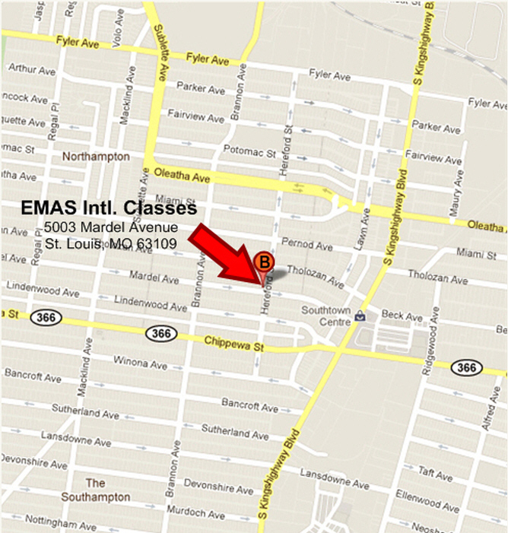
EMAS International
South St. Louis Dojo Location

